CHAPTER 6

TEACHING NOTES

I cover most of Chapter 6, but not all of the material in great detail. I use the example in Table 6.1 to quickly run through the effects of data scaling on the important OLS statistics. (Students should already have a feel for the effects of data scaling on the coefficients, fitting values, and R-squared because it is covered in Chapter 2.) At most, I briefly mention beta coefficients; if students have a need for them, they can read this subsection.

The functional form material is important, and I spend some time on more complicated models involving logarithms, quadratics, and interactions. An important point for models with quadratics, and especially interactions, is that we need to evaluate the partial effect at interesting values of the explanatory variables. Often, zero is not an interesting value for an explanatory variable and is well outside the range in the sample. Using the methods from Chapter 4, it is easy to obtain confidence intervals for the effects at interesting x values.

As far as goodness-of-fit, I only introduce the adjusted R-squared, as I think using a slew of goodness-of-fit measures to choose a model can be confusing to novices (and does not reflect empirical practice). It is important to discuss how, if we fixate on a high R-squared, we may wind up with a model that has no interesting ceteris paribus interpretation.

I often have students and colleagues ask if there is a simple way to predict y when log(y) has been used as the dependent variable, and to obtain a goodness-of-fit measure for the log(y) model that can be compared with the usual R-squared obtained when y is the dependent variable. The methods described in Section 6.4 are easy to implement and, unlike other approaches, do not require normality.

The section on prediction and residual analysis contains several important topics, including constructing prediction intervals. It is useful to see how much wider the prediction intervals are than the confidence interval for the conditional mean. I usually discuss some of the residual-analysis examples, as they have real-world applicability.

SOLUTIONS TO PROBLEMS

6.1 The generality is not necessary. The t statistic on roe² is only about −.30, which shows that roe² is very statistically insignificant. Plus, having the squared term has only a minor effect on the slope even for large values of roe. (The approximate slope is .0215 − .00016 roe, and even when roe = 25 – about one standard deviation above the average roe in the sample – the slope is .211, as compared with .215 at roe = 0.)

6.2 By definition of the OLS regression of c₀y_{i} on c₁x_{i1}, , c_{k}x_{ik}, i = 2, , n, the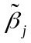 solve

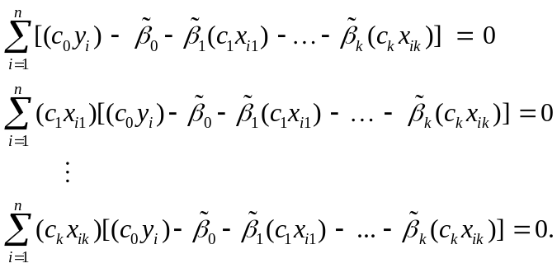

[We obtain these from equations (3.13), where we plug in the scaled dependent and independent variables.] We now show that if 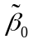 = 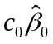 and = 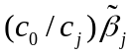, j = 1,…,k, then these k + 1 first order conditions are satisfied, which proves the result because we know that the OLS estimates are the unique solutions to the FOCs (once we rule out perfect collinearity in the independent variables). Plugging in these guesses for the gives the expressions

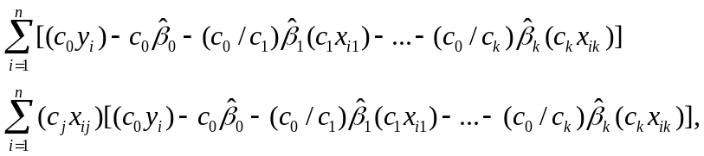

for j = 1,2,…,k. Simple cancellation shows we can write these equations as

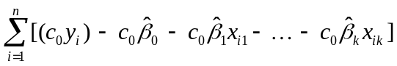
and
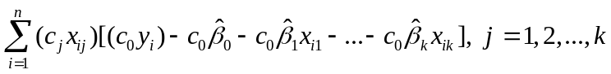

or, factoring out constants,

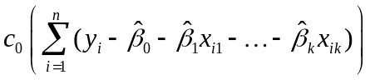
and
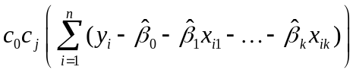, j = 1, 2,
But the terms multiplying c₀ and c₀c_{j} are identically zero by the first order conditions for the 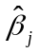 since, by definition, they are obtained from the regression y_{i} on x_{i1}, , x_{ik}, i = 1,2,..,n. So we have shown that = c₀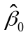 and = (c₀/c_{j}) , j = 1, , k solve the requisite first order conditions.

6.3 (i) The turnaround point is given by 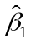/(2|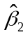|), or .0003/(.000000014) 21,428.57; remember, this is sales in millions of dollars.

(ii) Probably. Its t statistic is about –1.89, which is significant against the one-sided alternative H₀: 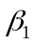 < 0 at the 5% level (cv –1.70 with df = 29). In fact, the p-value is about .036.

(iii) Because sales gets divided by 1,000 to obtain salesbil, the corresponding coefficient gets multiplied by 1,000: (1,000)(.00030) = .30. The standard error gets multiplied by the same factor. As stated in the hint, salesbil² = sales/1,000,000, and so the coefficient on the quadratic gets multiplied by one million: (1,000,000)(.0000000070) = .0070; its standard error also gets multiplied by one million. Nothing happens to the intercept (because rdintens has not been rescaled) or to the R²:

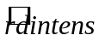 = 2.613 + .30 salesbil – .0070 salesbil²
(0.429) (.14) (.0037)
n = 32, R² = .1484.

(iv) The equation in part (iii) is easier to read because it contains fewer zeros to the right of the decimal. Of course the interpretation of the two equations is identical once the different scales are accounted for.

6.4 (i) Holding all other factors fixed we have

Dividing both sides by ∆educ gives the result. The sign of 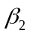 is not obvious, although > 0 if we think a child gets more out of another year of education the more highly educated are the child’s parents.

(ii) We use the values pareduc = 32 and pareduc = 24 to interpret the coefficient on educpareduc. The difference in the estimated return to education is .00078(32 – 24) = .0062, or about .62 percentage points.

(iii) When we add pareduc by itself, the coefficient on the interaction term is negative. The t statistic on educpareduc is about –1.33, which is not significant at the 10% level against a two-sided alternative. Note that the coefficient on pareduc is significant at the 5% level against a two-sided alternative. This provides a good example of how omitting a level effect (pareduc in this case) can lead to biased estimation of the interaction effect.

6.5 This would make little sense. Performances on math and science exams are measures of outputs of the educational process, and we would like to know how various educational inputs and school characteristics affect math and science scores. For example, if the staff-to-pupil ratio has an effect on both exam scores, why would we want to hold performance on the science test fixed while studying the effects of staff on the math pass rate? This would be an example of controlling for too many factors in a regression equation. The variable scill could be a dependent variable in an identical regression equation.

6.6 The extended model has df = 680 – 9 = 671, and we are testing two restrictions. Therefore, F = [(.232 – .229)/(1 – .232)](671/2) 1.31, which is well below the 10% critical value in the F distribution with 2 and ∞ df: cv = 2.30. Thus, atndrte² and ACTatndrte are jointly insignificant. Because adding these terms complicates the model without statistical justification, we would not include them in the final model.

6.7 The second equation is clearly preferred, as its adjusted R-squared is notably larger than that in the other two equations. The second equation contains the same number of estimated parameters as the first, and the one fewer than the third. The second equation is also easier to interpret than the third.

6.8 (i) The answer is not entire obvious, but one must properly interpret the coefficient on alcohol in either case. If we include attend, then we are measuring the effect of alcohol consumption on college GPA, holding attendance fixed. Because attendance is likely to be an important mechanism through which drinking affects performance, we probably do not want to hold it fixed in the analysis. If we do include attend, then we interpret the estimate of 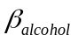as being those effects on colGPA that are not due to attending class. (For example, we could be measuring the effects that drinking alcohol has on study time.) To get a total effect of alcohol consumption, we would leave attend out.

(ii) We would want to include SAT and hsGPA as controls, as these measure student abilities and motivation. Drinking behavior in college could be correlated with one’s performance in high school and on standardized tests. Other factors, such as family background, would also be good controls.

SOLUTIONS TO COMPUTER EXERCISES

C6.1 (i) The causal (or ceteris paribus) effect of dist on price means that ≥ 0: all other relevant factors equal, it is better to have a home farther away from the incinerator. The estimated equation is

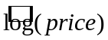 = 8.05 + .365 log(dist)
(0.65) (.066)
n = 142, R² = .180, 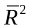 = .174,

which means a 1% increase in distance from the incinerator is associated with a predicted price that is about .37% higher.

(ii) When the variables log(inst), log(area), log(land), rooms, baths, and age are added to the regression, the coefficient on log(dist) becomes about .055 (se .058). The effect is much smaller now, and statistically insignificant. This is because we have explicitly controlled for several other factors that determine the quality of a home (such as its size and number of baths) and its location (distance to the interstate). This is consistent with the hypothesis that the incinerator was located near less desirable homes to begin with.

(iii) When [log(inst)]² is added to the regression in part (ii), we obtain (with the results only partially reported)

= –3.32 + .185 log(dist) + 2.073 log(inst) – .1193 [log(inst)]² +
(2.65) (.062) (0.501) (.0282)
n = 142, R² = .778, = .764.

The coefficient on log(dist) is now very statistically significant, with a t statistic of about three. The coefficients on log(inst) and [log(inst)]² are both very statistically significant, each with t statistics above four in absolute value. Just adding [log(inst)]² has had a very big effect on the coefficient important for policy purposes. This means that distance from the incinerator and distance from the interstate are correlated in some nonlinear way that also affects housing price.
We can find the value of log(inst) where the effect on log(price) actually becomes negative: 2.073/[2(.1193)] 8.69. When we exponentiate this we obtain about 5,943 feet from the interstate. Therefore, it is best to have your home away from the interstate for distances less than just over a mile. After that, moving farther away from the interstate lowers predicted house price.

(iv) The coefficient on [log(dist)]², when it is added to the model estimated in part (iii), is about -.0365, but its t statistic is only about -.33. Therefore, it is not necessary to add this complication.

C6.2 (i) The estimated equation is

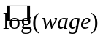 = .128 + .0904 educ + .0410 exper – .000714 exper²
(.106) (.0075) (.0052) (.000116)

n = 526, R² = .300, = .296.

(ii) The t statistic on exper² is about –6.16, which has a p-value of essentially zero. So exper is significant at the 1% level(and much smaller significance levels).

(iii) To estimate the return to the fifth year of experience, we start at exper = 4 and increase exper by one, so Δexper = 1:

Similarly, for the 20th year of experience,

(iv) The turnaround point is about .041/[2(.000714)] 28.7 years of experience. In the sample, there are 121 people with at least 29 years of experience. This is a fairly sizeable fraction of the sample.

C6.3 (i) Holding exper (and the elements in u) fixed, we have

or
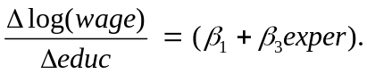

This is the approximate proportionate change in wage given one more year of education.

(ii) H₀: 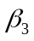 = 0. If we think that education and experience interact positively – so that people with more experience are more productive when given another year of education – then > 0 is the appropriate alternative.

(iii) The estimated equation is

= 5.95 + .0440 educ – .0215 exper + .00320 educexper
(0.24) (.0174) (.0200) (.00153)
n = 935, R² = .135, = .132.

The t statistic on the interaction term is about 2.13,which gives a p-value below .02 against H₁: > 0. Therefore, we reject H₀: = 0 against H₁: > 0 at the 2% level.

(iv) We rewrite the equation as

log(wage) = 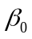 + 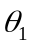educ + exper + educ(exper – 10) + u,

and run the regression log(wage) on educ, exper, and educ(exper – 10). We want the coefficient on educ. We obtain 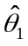 .0761 and se() .0066. The 95% CI for is about .063 to .089.

C6.4 (i) The estimated equation is

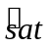 = 997.98 + 19.81 hsize – 2.13 hsize²
(6.20) (3.99) (0.55)
n = 4,137, R² = .0076.

The quadratic term is very statistically significant, with t statistic –3.87.

(ii) We want the value of hsize, say hsize*, where 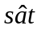 reaches its maximum. This is the turning point in the parabola, which we calculate as hsize* = 19.81/[2(2.13)] 4.65. Since hsize is in 100s, this means 465 students is the “optimal” class size. Of course, the very small R-squared shows that class size explains only a tiny amount of the variation in SAT score.

(iii) Only students who actually take the SAT exam appear in the sample, so it is not representative of all high school seniors. If the population of interest is all high school seniors, we need a random sample of such students who all took the same standardized exam.

(iv) With log(sat) as the dependent variable we get

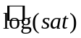 = 6.896 + .0196 hsize – .00209 hsize²
(0.006) (.0040) (.00054)
n = 4,137, R² = .0078.

The optimal class size is now estimated as about 469, which is very close to what we obtained with the level-level model.

C6.5 (i) The results of estimating the log-log model (but with bdrms in levels) are

= 5.61 + .168 log(lotsize) + .700 log (sqrft) + .037 bdrms
(0.65) (.038) (.093) (.028)
n = 88, R² = .634, = .630.

(ii) With lotsize = 20,000, sqrft = 2,500, and bdrms = 4, we have

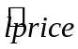 = 5.61 + .168log(20,000) + .700log(2,500) + .037(4) 12.90

where we use lprice to denote log(price). To predict price, we use the equation 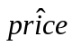 = 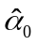exp(), where is the slope on 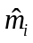 ≡ exp() from the regression price_{i} on , i = 1,2, , 88 (without an intercept). When we do this regression we get 1.023. Therefore, for the values of the independent variables given above, 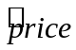 (1.023)exp(12.90) $409,519 (rounded to the nearest dollar). If we forget to multiply by the predicted price would be about $400,312.

(iii) When we run the regression with all variables in levels, the R-squared is about .672. When we compute the correlation between price_{i} and the from part (ii), we obtain about .859. The square of this, or roughly .738, is the comparable goodness-of-fit measure for the model with log(price) as the dependent variable. Therefore, for predicting price, the log model is notably better.

C6.6 (i) For the model

voteA = + prtystrA + expendA + expendB + 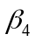expendAexpendB + u,

the ceteris paribus effect of expendB on voteA is obtained by taking changes and holding prtystrA, expendA, and u fixed:

ΔvoteA = ΔexpendB + expendA(ΔexpendB) = ( + expendA) ΔexpendB,
or
ΔvoteA/ΔexpendB = + expendA.

We think < 0 if a ceteris paribus increase in spending by B lowers the share of the vote received by A. But the sign of is ambiguous: Is the effect of more spending by B smaller or larger for higher levels of spending by A?

(ii) The estimated equation is

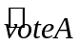 = 32.12 + .342 prtystrA + .0383 expendA – .0317 expendB
(4.59) (.088) (.0050) (.0046)
– .0000066 expendAexpendB
(.0000072)
n = 173, R² = .571, = .561.

The interaction term is not statistically significant, as its t statistic is less than one in absolute value.

(iii) The average value of expendA is about 310.61, or $310,610. If we set expendA at 300, which is close to the average value, we have

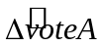 = [–.0317 – .0000066(300)] ΔexpendB –.0337(ΔexpendB).

So, when ΔexpendB = 100, –3.37, which is a fairly large effect. (Note that, given the insignificance of the interaction term, we would be justified in leaving it out and reestimating the model. This would make the calculation easier.)

(iv) Now we have

= ( + 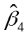expendB)ΔexpendA .0376(ΔexpendA) = 3.76

when ΔexpendA = 100. This does make sense, and it is a nontrivial effect.

(v) When we replace the interaction term with shareA we obtain

= 18.20 + .157 prtystrA − .0067 expendA + .0043 expendB + .494 shareA
(2.57) (.050) (.0028) (.0026) (.025)
n = 173, R² = .868, = .865.

Notice how much higher the goodness-of-fit measures are as compared with the equation estimated in part (ii), and how significant shareA is. To obtain the partial effect of expendB on 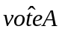we must compute the partial derivative. Generally, we have

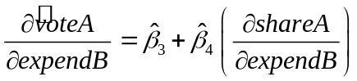,

where shareA = 100[expendA/(expendA + expendB)]. Now

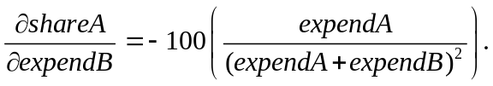

Evaluated at expendA = 300 and expendB = 0, the partial derivative is –100(300/300²) = −1/3, and therefore

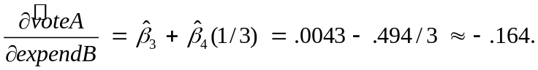

So falls by .164 percentage points given the first thousand dollars of spending by candidate B, where A’s spending is held fixed at 300 (or $300,000). This is a fairly large effect, although it may not be the most typical scenario (because it is rare to have one candidate spend so much and another spend so little). The effect tapers off as expendB grows. For example, at expendB = 100, the effect of the thousand dollars of spending is only about .0043 − .494(.188) –.089.

C6.7 (i) If we hold all variables except priGPA fixed and use the usual approximation Δ(priGPA²) 2(priGPA)⋅ΔpriGPA, then we have

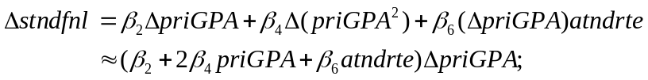

dividing by ∆priGPA gives the result. In equation (6.19) we have = −1.63, = .296, and 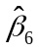= .0056. When priGPA = 2.59 and atndrte = .82 we have

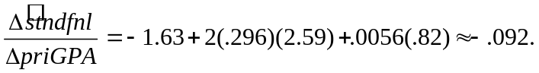

(ii) First, note that (priGPA – 2.59)² = priGPA² – 2(2.59)priGPA + (2.59)² and priGPA(atndrte − .82) = priGPAatndrte – (.82)priGPA. So we can write equation 6.18) as

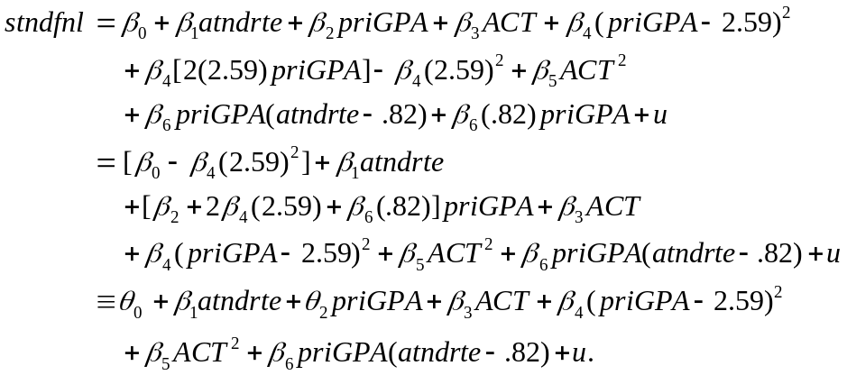

When we run the regression associated with this last model, we obtain 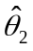 -.091 [which differs from part (i) by rounding error] and se() .363. This implies a very small t statistic for .

C6.8 (i) The estimated equation (where price is in dollars) is

= −21,770.3 + 2.068 lotsize + 122.78 sqrft + 13,852.5 bdrms
(29,475.0) (0.642) (13.24) (9,010.1)
n = 88, R² = .672, = .661, 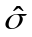 = 59,833.

The predicted price at lotsize = 10,000, sqrft = 2,300, and bdrms = 4 is about $336,714.

(ii) The regression is price_{i} on (lotsize_{i} – 10,000), (sqrft_{i} – 2,300), and (bdrms_{i} – 4). We want the intercept estimate and the associated 95% CI from this regression. The CI is approximately 336,706.7 ± 14,665, or about $322,042 to $351,372 when rounded to the nearest dollar.

(iii) We must use equation (6.36) to obtain the standard error of 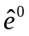 and then use equation (6.37) (assuming that price is normally distributed). But from the regression in part (ii), se(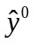) 7,374.5 and 59,833. Therefore, se() [(7,374.5)² + (59,833)²]^{1/2} 60,285.8. Using 1.99 as the approximate 97.5th percentile in the t₈₄ distribution gives the 95% CI for price⁰, at the given values of the explanatory variables, as 336,706.7 ± 1.99(60,285.8) or, rounded to the nearest dollar, $216,738 to $456,675. This is a fairly wide prediction interval. But we have not used many factors to explain housing price. If we had more, we could, presumably, reduce the error standard deviation, and therefore , to obtain a tighter prediction interval.

C6.9 (i) The estimated equation is

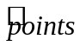 = 35.22 + 2.364 exper − .0770 exper² − 1.074 age − 1.286 coll
(6.99) (.405) (.0235) (.295) (.451)
n = 269, R² = .141, = .128.

(ii) The turnaround point is 2.364/[2(.0770)] ≈ 15.35. So, the increase from 15 to 16 years of experience would actually reduce salary. This is a very high level of experience, and we can essentially ignore this prediction: only two players in the sample of 269 have more than 15 years of experience.

(iii) Many of the most promising players leave college early, or, in some cases, forego college altogether, to play in the NBA. These top players command the highest salaries. It is not more college that hurts salary, but less college is indicative of super-star potential.

(iv) When age² is added to the regression from part (i), its coefficient is .0536 (se = .0492). Its t statistic is barely above one, so we are justified in dropping it. The coefficient on age in the same regression is –3.984 (se = 2.689). Together, these estimates imply a negative, increasing, return to age. The turning point is roughly at 74 years old. In any case, the linear function of age seems sufficient.

(v) The OLS results are

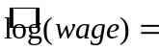 6.78 + .078 points + .218 exper − .0071 exper² − .048 age − .040 coll
(.85) (.007) (.050) (.0028) (.035) (.053)

n = 269, R² = .488, 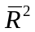= .478

(vi) The joint F statistic produced by Stata is about 1.19. With 2 and 263 df, this gives a p-value of roughly .31. Therefore, once scoring and years played are controlled for, there is no evidence for wage differentials depending on age or years played in college.

C6.10 (i) The estimated equation is

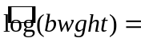 7.958 + .0189 npvis − .00043 npvis²
(.027) (.0037) (.00012)

n = 1,764, R² = .0213, = .0201

The quadratic term is very significant as its t statistic is above 3.5 in absolute value.

(ii) The turning point calculation is by now familiar: 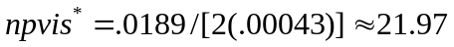, or about 22. In the sample, 89 women had 22 or more prenatal visits.

(iii) While prenatal visits are a good thing for helping to prevent low birth weight, a woman’s having many prenatal visits is a possible indicator of a pregnancy with difficulties. So it does make sense that the quadratic has a hump shape, provided we do not interpret the turnaround as implying that too many visits actually causes low birth weight.

(iv) With mage added in quadratic form, we get

7.584 + .0180 npvis − .00041 npvis² + .0254 mage − .00041 mage²
(.137) (.0037) (.00012) (.0093) (.00015)

n = 1,764, R² = .0256, = .0234

The birth weight is maximized at mage ≈ 31. 746 women are at least 31 years old; 605 are at least 32.

(v) These variables explain on the order of 2.6% of the variation in log(bwght) (or even less according to), which is not very much.

(vi) If we regress bwght on npvis, npvis², mage, and mage², then R² = .0192. But remember, we cannot compare this directly with the R-squared reported in part (iv). Instead, we compute an R-squared for the log(bwght) model that can be compared with .0192. From Section 6.4, we compute the squared correlation between bwght and 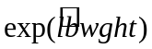, where 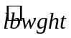 denotes the fitted values from the log(bwght) model. The correlation is .1362, so its square is about .0186. Therefore, for explaining bwght, the model with bwght as the dependent variable actually fits slightly better (but nothing to make a big deal about).

C6.11 (i) The results of the OLS regression are

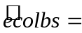 1.97 − 2.93 ecoprc + 3.03 regprc
(0.38) (0.59) (0.71)

n = 660, R² = .036, = .034

As predicted by economic theory, the own price effect is negative and the cross price effect is positive. In particular, an increase in ecoprc of .10, or 10 cents per pound, reduces the estimated demand for eco-labeled apples by about .29 lbs. A ceteris paribus increase of 10 cents per lb. for regular applies increases the estimated demand for eco-labeled apples by about .30 lbs. These effects, which are essentially the same magnitude but of opposite sign, are fairly large.

(ii) Each price variable is individually statistically significant with t statistics greater than four (in absolute value) in both cases. The p-values are zero to at least three decimal places.

(iii) The fitted values range from a low of about .86 to a high of about 2.09. This is much less variation than ecoblbs itself, which ranges from 0 to 42 (although 42 is a bit of an outlier). There are 248 out of 660 observations with ecolbs = 0 and these observations are clearly not explained well by the model.

(iv) The R-squared is only about 3.6% (and it does not really matter whether we use the usual or adjusted R-squared). This is a very small explained variation in ecolbs. So the two price variables do not do a good job of explaining why ecolbs_{i} varies across families.

(v) When faminc, hhsize, educ, and age are added to the regression, the R-squared only increases to about .040 (and the adjusted R-squared falls from .034 to .031). The p-value for the joint F test (with 4 and 653 df) is about .63, which provides no evidence that these additional variables belong in the regression. Evidently, in addition to the two price variables, the factors that explain variation in ecolbs (which is, remember, a counterfactual quantity), are not captured by the demographic and economic variables collected in the survey. Almost 97 percent of the variation is due to unobserved “taste” factors.

C6.12 (i) The youngest age is 25, and there are 99 people of this age in the sample with fsize = 1.

(ii) One literal interpretation is that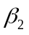 is the increase in nettfa when age increases by one year, holding fixed inc and age². Of course, it makes no sense to change age while keeping age² fixed. Alternatively, because 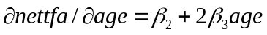 , is the approximate increase in nettfa when age increases from zero to one. But in this application, the partial effect starting at age = 0 is not interesting; the sample represents single people at least 25 years old.

(iii) The OLS estimates are

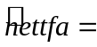 −1.20 + .825 inc − 1.322 age + .0256 age²
(15.28) (.060) (0.767) (.0090)

n = 2,017, R² = .1229, = .1216

Initially, the negative coefficient on age may seem counterintuitive. The estimated relationship is a U-shape, but, to make sense of it, we need to find the turning point in the quadratic. From equation (6.13), the estimated turning point is 1.322/[2(.0256)] ≈ 25.8. Interestingly, this is very close to the youngest age in the sample. In other words, starting at roughly age = 25, the relationship between nettfa and age is positive – as we might expect. So, in this case, the negative coefficient on age makes sense when we compute the partial effect.

(iv) I follow the hint, form the new regressor 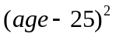, and run the regression nettfa on inc, age, and . This changes the intercept (which we are not concerned with, anyway) and the coefficient on age, which is simply 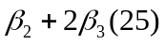 – the partial effect evaluated at age = 25 . The results are

−17.20 + .825 inc − .0437 age + .0256 (age −25) ²
(9.97) (.060) (.767) (.0090)

n = 2,017, R² = .1229, = .1216

Therefore, the estimated partial effect starting at age = 25 is only −.044 and very statistically insignificant (t = −.13). The two-sided p-value is about .89.

(v) If we drop age from the regression in part (iv) we get

−18.49 + .824 inc + .0244 (age −25) ²
(2.18) (.060) (.0025)

n = 2,017, R² = .1229, = .1220

The adjusted R-squared is slightly higher when we drop age. But the real reason for dropping age is that its t statistic is quite small, and the model without it has a straightforward interpretation.

(vi) The graph of the relationship estimated in (v), with inc = 30, is

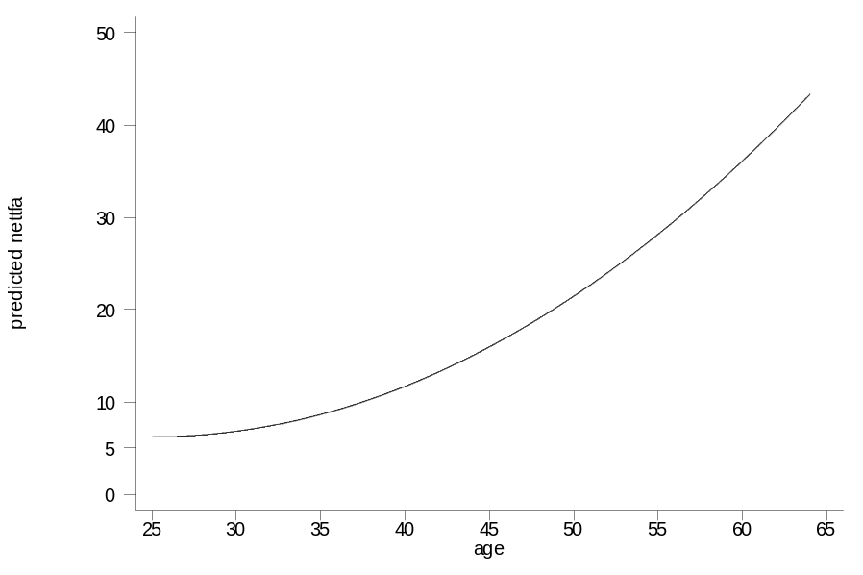
The slope of the relationship between 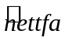 and age is clearly increasing. That is, there is an increasing marginal effect. The model is constructed so that the slope is zero at age = 25; from there, the slope increases.

(vii) When inc² is added to the regression in part (v) its coefficient is only −.00054 with t = −0.27. Thus, the linear relationship between nettfa and inc is not rejected, and we would exclude the squared income term.

